HealthHub: Symptom Checker & Doctor Finder
Name: Manvesh Singh | UID :24BCS10752 | Date: January 2026

1. Overview
Problem: People visit wrong doctors, waste time and money.
Solution: Enter symptoms → Get disease predictions → Find nearby doctors → Book appointment.

2. Technology Stack
Frontend: React.js, Tailwind CSS, Axios
Backend: Node.js, Express.js, JWT authentication
Database: PostgreSQL, MongoDB, Redis
APIs: Google Maps, Twilio (SMS)
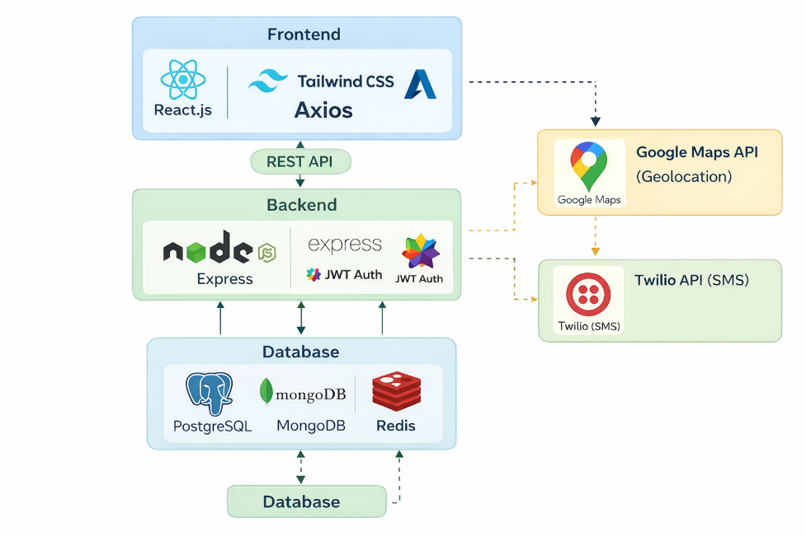

3. Core Features
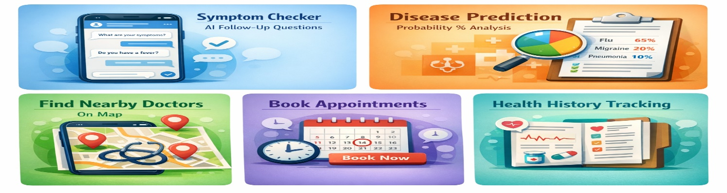

4. Data Structures & Algorithms
Graph (Medical Knowledge)
Connect symptoms to diseases | BFS traversal | O(V + E)
Decision Tree (Questions)
Smart follow-up questions | DFS | O(log n)
Trie (Search)
Autocomplete for symptoms/doctors | O(m)
KD-Tree (Location)
Find nearest doctors | O(log n)
Priority Queue (Ranking)
Rank doctors by distance, rating, availability | O(n log k)
HashMap
Fast lookups for caching | O(1)
Bayesian Probability
Calculate disease likelihood from symptoms | O(D × S)

5. System Flow
Symptom Analysis:
User selects symptoms → Graph finds diseases → Decision tree asks questions → Bayesian calculates % → Show top 3 diseases
Doctor Search:
Get location → KD-Tree finds nearby → Filter by specialization → Priority Queue ranks → Show top 10

6. Database Schema
Users, Symptoms
Diseases
Doctors,
Appointments
Symptom_disease

7. Timeline
Week 1: Setup, authentication, UI
Week 2: Graph, decision tree, Bayesian
Week 3: KD-Tree, doctor search, Maps
Week 4: Appointments, testing, deployment

8. Why This Project
6 DSA structures, 3+ algorithms
Full-stack: React + Node + PostgreSQL
Solves real healthcare problem
Unique and scalable

9. Learning Outcomes
DSA: Graphs, Trees, Heaps, Tries, Hashing, Probabilistic algorithms
Development: REST APIs, Authentication, Database optimization, Geolocation

Conclusion
HealthHub applies advanced Data Structures and Algorithms to solve healthcare accessibility problems through intelligent symptom analysis and location-based doctor discovery.

